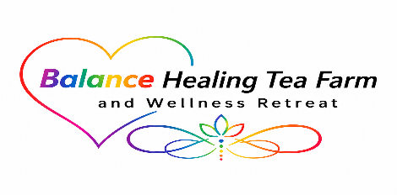
Balance Wellness Foundation

Residential Healing Retreat Program
The Balance Wellness Foundation offers a 7-Day Residential Healing Retreat for selected participants. This retreat provides a safe, peaceful environment where veterans and their families can focus on spiritual, mental, and physical healing.

Length of Stay
- Maximum Stay: 7 Days (1 Week)
- Check-In Date: ____________________
- Check-Out Date: ___________________

Retreat Accommodations
Participants will stay in a furnished trailer located on the Foundation's farm property. Accommodations are intended to provide a quiet, comfortable setting that encourages rest, reflection, and personal growth.

During Your Stay
Participants may engage in:
Spiritual Healing
- Prayer
- Meditation
- Sound Therapy
- Grounding Activities
- Spiritual Guidance
Mental & Emotional Healing
- Story Sharing
- Grief Support
- Life Repair Sessions
- Goal Setting
- Stress Reduction Practices
Physical Healing
- Farm Activities
- Gardening
- Fishing
- Exercise
- Cooking Together
- Nature Walks

Participant Agreement
By accepting placement in the Residential Healing Retreat Program, I understand:
☐ My stay is limited to seven (7) consecutive days.
☐ I agree to respect the property, staff, volunteers, and other participants.
☐ I will participate in activities at my own comfort level.
☐ I understand that the Foundation is not a medical treatment facility and does not provide emergency medical care.
☐ I agree to follow all safety guidelines during my stay.
Participant Signature: _______________________
Date: ____ / ____ / ______

Participant Assistance Application

Applicant Information
Full Name: ______________________________________
Date of Birth: ____ / ____ / ______
Gender: ______________________________________
Address: ______________________________________

City: __________________ State: ______ Zip: ______
Phone Number: ________________________________
Email Address: _________________________________

Military Service Information
Are you:
☐ Veteran
☐ Active Duty
☐ Military Spouse
☐ Military Dependent
☐ Gold Star Family Member
Branch of Service: ____________________________
Years of Service: _____________________________

Family Information
Marital Status:
☐ Single
☐ Married
☐ Divorced
☐ Widowed
Number of Household Members: ________________
Names and Ages of Children Living in Household:
Loss and Grief Information
Who was lost?
☐ Parent
☐ Child
☐ Other Family Member
Name of Deceased (Optional): ___________________
Date of Loss: ____ / ____ / ______
Briefly describe how this loss has impacted your family:

Assistance Requested
Please check all services you are interested in:
☐ Grief Support Programs
☐ Family Wellness Retreats
☐ Educational Workshops
☐ Financial Assistance
☐ Counseling Referrals
☐ Children's Programs
☐ Community Support Events
☐ Other: _____________________________________

Medical Information
Primary Care Physician (Optional):
Name: ______________________________________
Phone: ______________________________________
Medical Conditions We Should Be Aware Of:

Current Medications:
Medication | Dosage | Reason
Allergies:

Emergency Contact
Name: ______________________________________
Relationship: ________________________________
Phone Number: ________________________________

Personal Statement
Please tell us why you are applying and how our programs may benefit you and your family:

Certification
I certify that the information provided in this application is true and accurate to the best of my knowledge.
Applicant Signature: ______________________________
Date: ____ / ____ / ______

Foundation Use Only
Application Received: ____ / ____ / ______
Reviewed By: __________________________________
Status:
☐ Approved
☐ Pending
☐ Denied
Notes:

